**Statistical Modelling Summary Sheet – HS 2023**

**Background – Linear Algebra & Calculus:**

* **Trace**: $tr\left(A\right)=∑A_{ii}$  
  linear: $tr\left(aA+bB\right)=a tr\left(A\right)+b tr(B)$  
  cyclic: $tr\left(ABC\right)=tr\left(BCA\right)=tr\left(CAB\right)$
* **Rank**: $rnk\left(A\right)=$ largest number of rows (columns) of A   
  that constitute a linearly independent set.
* **Range space $R\left(A\right)=\left\{y:y=Ax\right\}$**   
  **Null space $N\left(A\right)=\left\{x:Ax=0\right\}$**   
  - $rnk\left(A\right)=\dim\left(R\left(A\right)\right)=n-dim⁡(N\left(A\right))$
* **Orthogonal** matrix:   
  - square matrix; cols and rows are orthonormal vectors
* **Symmetric** matrix:   
  - Spectral decomposition: $A=QDQ^{T}$
* **Quadratic form**: $x^{T}Ax$
* **Positive definite** (pd) matrix: $x^{T}Ax>0 for all x∈R^{n} ∖\left\{0\right\}$  
  Positive semi-definite (psd) matrix:   
  - Eigenvalues, trace, det are pos (non-neg)  
  - Square root: $A^{-\frac{1}{2}}$, Cholesky decomposition (${A=L}^{T}L$; with $L$ lower triangular matrix)
* **Orthogonal Projection**:   
  - idempotent ($P=P^{2}$), symm. ()  
  - )  
  - Eig.val. in $\left\{0,1\right\}$; geom. multiplicity of eig.val. 1 is   
  - is also projection (onto orthogonal complement of P);   
  - If cols of B are basis of subspace S, og. projection on S is $$P_{S}=B{\left(B^{T}B\right)}^{-1}B^{T}$$ 
  (simple special case: ONB (orthonormal) $→P_{S}=QQ^{T}$)
* **Cauchy-Schwarz** Inequality: $|<u,v>{\left.​\right|}^{2}≤ <u,u>⋅<v,v>$
* **Differentiation (Fahrmeir, A.8): $$\frac{∂y^{T}x}{∂x}=y ;\frac{∂x^{T}Ax}{∂x}=\left(A+A^{T}\right)x ;\frac{∂Ax}{∂x}=A^{T};\frac{∂Ax}{∂x^{T}}=A$$**

**Background – Probability:**

* **Expected Value**: $E\left[X\right]=μ=∫xf\left(x\right)dx$;

arithmetic mean: $\hat{μ}=\frac{1}{n}∑x_{i}$

* **Variance**: $Var\left(X\right)=E\left[{\left(X-E[X]\right)}^{2}\right]=E\left[X^{2}\right]-{\left(E\left[X\right]\right)}^{2}$; empirical: $\hat{var}\left(X\right)=\frac{1}{n-1}∑{\left(x_{i}-\hat{μ}\right)}^{2}$
* **Covariance**: $Cov\left(X,Y\right)=σ_{X,Y}=E\left[\left(X-E\left[X\right]\right){\left(Y-E\left[Y\right]\right)}^{T}\right]$; empirical: $\hat{cov}\left(X,Y\right)={\hat{σ}}_{X,Y}=$

$\frac{1}{n-1}∑\left(x_{i}-{\hat{μ}}_{X}\right){\left(y_{i}-{\hat{μ}}_{Y}\right)}^{T}$ (in mult. dim. write: ${\hat{Σ}}_{X,Y}$ )

* **Independence**: $X⊥Y↔P\left(X∩Y\right)=P\left(X\right)*P\left(Y\right)$;

In general: $X⊥Y→Cov\left(X,Y\right)=0$

* **Important pars: $μ, σ_{X}, σ_{X,Y}, Σ_{X}$**
* **Trafo Expectation: $E\left(AY+a\right)=A E\left(Y\right)+a$**
* **Trafo Covariance matrix: $Var\left(AY+a\right)=A Var\left(Y\right) A^{T}$**
* **Normal distribution (1-dim): $Z\sim N\left(0,1\right);Y=μ+σZ→Y\sim N\left(μ,σ^{2}\right)$** (Senn, B3)

-rule of thumb: $μ ±2*σ$ covers about 95% of the CI **Standardize: $Y \sim N\left(μ,σ^{2}\right)→Z≔\frac{Y-μ}{σ}\sim N(0,1)$**

* **N (n-dim): $Z=\left(Z_{1},…,Z_{n}\right), Z_{i}\sim N\left(0,1\right) i.i.d. →Z \sim N\left(0,I_{n}\right)$ $Y=μ+AZ→Y \sim N\left(μ, Σ\right)$**  with $Σ=AA^{T}$
* **Normal is special:**  *- $Cov\left(Y_{i},Y_{j}\right)=0 ↔Y_{i}⊥Y_{j}$  
  - $Y\sim N\left(μ, Σ\right)→A Y \sim N\left(Aμ, AΣA^{T}\right)$*    
  - $Y\sim N\left(μ, σ^{2}1_{n*n}\right), nrow\left(A\right)+nrow\left(B\right)≤n:$ $U=AY, V=BY:U⊥V↔AB^{T}=0$
* **Chi-square: $Z\sim N\left(0,1\right); Z^{2}\sim Χ_{1}^{2}$** ; $\sum_{i=1}^{n}{Z_{i}^{2}\sim Χ^{2}, if Z_{i}⊥Z_{j}}$; $Y\sim N\left(μ,Σ\right)→{\left(Y-μ\right)}^{T}Σ^{-1}\left(Y-μ\right)\sim Χ_{n}^{2}$ 
     
  **degenerate case**: If $e \sim N(0,M)$, $M∈R^{n*n}$ idempotent with $rnk\left(M\right)=r<n$. Then: $e^{T}Me∼Χ_{r}^{2}$
* **F-distribution**: $X \sim Χ_{m}^{2}, Y\sim Χ_{n}^{2}, X⊥Y:\frac{\left(\frac{X}{m}\right)}{\frac{Y}{n}}\sim F_{m,n}$;

Also: $T\sim F_{m,n}$: $E\left[T\right]=\frac{n}{n-2}$

* **T-distribution: $Z\sim N\left(0,1\right), V\sim Χ_{k}^{2}, Z⊥V:$ $T=\frac{Z}{\sqrt{\frac{V}{k}}}\sim t_{k}$**  ;Also: ${X\sim t}_{k}→X^{2}\sim F_{1,k}$; t-distr. is like normal distr.
* **Classical CLT: $X_{i}\sim F, E\left(X_{i}\right)=μ, Var\left(X_{i}\right)=σ^{2}<∞, i.i.d$**  : ${\sqrt{n}(\overline{X}}_{n}-μ)→N(0,σ^{2})$ ($n→∞$)

$\frac{1}{\sqrt{n}*σ}∑(x_{i}-μ)→N(0,1)$ ($n→∞$)

* **\*Lindeberg CLT:** Similar for independent, but not identically distributed RVs (needs **Lindeberg’s condition**)

**Background – Statistics:**

* $β$**: true parameter, $\hat{β}$ estimated par. (with «hat»)**
* **Point estimate: MLE** selects par. value which gives the observed data the largest possible probability (or prob. density in cont. case)
* **MLE has great properties (given some assumptions):  
  - Consistent: $\hat{θ}→θ$**  (in prob. as )  
  - **Asy. Normal**: $\sqrt{n}\left(\hat{θ}-θ\right)→N(0, I^{-1})$ (in distr. as

$n→∞$) where $I$ is Fisher Information  
- **Efficient**: Asymptotically Unbiased and smallest possible variance

* **Likelihood Ratio Test (LRT) has great properties** (given some assumptions):  
  - Neyman-Pearson Lemma: LRT has **largest power**- **Asymptotic Distribution** is known

**Hypothesis test**

* **6 steps**: Model (r.v.’s + their distribution $P_{θ}$), hypotheses, test stat. & distribution (of the test statistic),level of significance $α$, rejection region, decision
* **Type 1 error**: $H_{0}$ true, but rejected; $$P\left(Type 1 error\right)≤α$$
* **Type 2 error**: $H_{0}$ wrong, but no rejected; $$power=1-P\left(Type 2 error\right)$$ 
  To compute power, you need **concrete alternative**
* In general: $α$ smaller $→$ power smaller  
  Solution: More samples
* **One-sided test** can have more power than two-sided test, but “blind” on one side
* **p-value**: Assume $H_{0}$ is true, how likely is observation or something more extreme? (or: Smallest $α$ with which we can reject)

$H_{0}$ true: p-value is uniformly distributed on $[0,1]$

$H_{1}$ true: small p-values are more likely

* $(1-α)$-**confidence interval** for parameter:   
  Contains true parameter with prob $1-α$

(or: all parameters, where $H_{0}$ is not rejected by a test at level $α$); rule of thumb for $95\%$ interval: ${\overline{X}}_{n}±2*\frac{{\hat{σ}}_{X}}{\sqrt{n}}$

* **z-Test**:  
  - Test for **expected value $μ$** of $N\left(μ, σ^{2}\right)$;  
  assume $σ$ is known (usually unrealistic)  
  - Test statistic:   
  - Assuming $H_{0}$: $Z \sim N(0,1)$
* **t-Test** (1 sample; this is Likelihood Ratio Test):  
  - Test for **expected value $μ$**  of $N\left(μ, σ^{2}\right)$; $σ$**not known**  
  - Test statistic: $T=\frac{{\overline{X}}_{n}-μ_{0}}{\frac{{\hat{σ}}_{X}}{\sqrt{n}}}$ (! hat on !)  
  - Assuming :

- Usually wider distribution compared to z-test

* Problem of **multiple Testing** (on same data):  
  FWER =

- at 95% level, 5% of tests will falsely (not) reject $→$ false positives  
- Bonferroni correction (modified $α$ value): Use $\tilde{α}=\frac{α}{m}$ level for every individual test => FWER= $α$

**Measuring association**

* **Pearson correlation:**  ()

- corrects for scaling of variances (cov. depeds on unit)

* $ρ_{X,Y}=0→$ X and Y are «uncorrelated»; $\left|ρ_{X,Y}\right|≤1$

If $\left|ρ_{X,Y}\right|=1$, then $X=Y$ or $X=-Y$,i.e. points are on straight line $→$ degree of *linear dependence*

- **BUT**: does **not** capture all kinds of dependence!

* **Inference via Fisher z-Trafo:** (statistic) $$Z=tanh^{-1}\left(\hat{ρ}\right)=\frac{1}{2}log\left(\frac{1+\hat{ρ}}{1-\hat{ρ}}\right)$$

$\hat{ρ}$ : empirical correlation

- Assume $\left(X,Y\right)∼N$: $Z≈N\left(\tanh^{-1}\left(ρ\right),\frac{1}{n-3}\right)$

* **Spearman correlation**: Pearson cor. on ranks,  
  detects monotonic relationsships
* Caveat:   
  (1) Indep. $→$ Cor=0 **but** Cor=0 ↛ Independent; equivalence holds for jointly normal random variables

(2) Correlation $≠$ causation

**Simple Linear Regression (SLR)**

* Regression: continuous response variable; continuous/categorical predictor variables
* Equivalent models: $Y_{i}=β_{0}+β_{1}x_{i}+ε_{i}= μ\left(x_{i}\right) +ε_{i}, ε_{i}\sim N\left(0,σ^{2}\right) i.i.d.$ 
   ; $Y_{i}\sim N\left(μ\left(x_{i}\right), σ^{2}\right) i.i.d.$ where $μ\left(x\right)=β_{0}+β_{1}x$
* OLS: $\hat{β}$’s minimize $∑{\left(y_{i}-\left({\hat{β}}_{0}+{\hat{β}}_{1}x_{i}\right)\right)}^{2}$**(RSS**)

RSS: sum of squared residuals

* If $ε_{i}\sim N\left(0,σ^{2}\right) i.i.d.$*:* **OLS = MLE** (they coincide)
* ${\hat{β}}_{1}=\frac{{\hat{σ}}_{x,y}}{{\hat{σ}}_{x}^{2}}$*; ${\hat{β}}_{0}={\overline{y}}_{n}-{\hat{β}}_{1}{\overline{x}}_{n}$ $→$* line through center of mass
* ${\hat{β}}_{1}={\hat{ρ}}_{XY}⋅\frac{{\hat{σ}}_{Y}}{{\hat{σ}}_{X}}$ ( $→$ slope is scaled correlation)
* Regression to mean: : $\frac{\hat{y}-{\overline{y}}_{n}}{{\hat{σ}}_{Y}}={\hat{ρ}}_{XY}⋅\frac{x-{\overline{x}}_{n}}{{\hat{σ}}_{X}}$
* Estimated coefs are random, **usually «wrong»**. Will never fit true exact value, since $Y (ϵ\sim N)$ is random.

**Multiple Linear Regression (MLR)**

* Excplicit form:

$Y_{i}=β_{0}+β_{1}x_{1,i}+β_{2}x_{2,i}+…+β_{p-1}x_{p-1,i}+ε_{i}= μ\left(x_{i}\right) +ε_{i}, ε_{i}\sim N\left(0,σ^{2}\right) i.i.d.$

* Vector form:

$Y_{i}=x_{i}^{T}β+ε_{i},{ ε}_{i}\sim N\left(0,σ^{2}\right) i.i.d.$

* **Matrix form:** (intercept: first X-col of only 1’s) $Y=Xβ+ε, ε\sim N(0, σ^{2}⋅1)$
* Transformations: (linearize non-linear functions)  
  exponential type: $\log\left(y\right)=\tilde{y}$  
  power type:

- for fitting non-linear data by linearizing (e.g. $y=\exp\left(xβ+ϵ\right);regress \tilde{y}=log⁡(y)$; for prediction transform back)

- example: $y=exp⁡(1+2\sin\left(x\right)+ϵ)$; $\tilde{x}=sin⁡(x)$

* Thus: many complicated models can be represented as a linear model (by linearizing the data)
* OLS: $\hat{β}=argmin_{β}\sum_{i=1}^{n}{{\left(y_{i}-β_{0}-β_{1}x_{1,i}-…-β_{p-1}x_{p-1,i}\right)}^{2}}=argmin_{β}{\left|Y-Xβ\right|}^{2}=argmin_{β} RSS$
* Same as MLE if $ε_{i}\sim N\left(0,σ^{2}\right) i.i.d.$
* **Convex**: Gradient descent etc. works
* Analytical Solution of MLR:   
  Normal eq.: $X^{T}\left(Y-X \hat{β}\right)=0$ (from setting RSS to 0)  
  Solution**: $\hat{β}={\left(X^{T}X\right)}^{-1}X^{T}Y$**
* Geometric interpretation: $\hat{Y}$**is orthogonal projection** ($H=X{\left(X^{T}X\right)}^{-1}X^{T}$) of $Y$ on hyperplane spanned by cols of $X$.
* **H**at matrix: $\hat{Y}=HY$; $tr\left(H\right)=p$
* Residual **M**aker:

- M: projection onto orthogonal complement of H

* Consequences of og. projection (ass. Gaussian errors **CHECK**): (note: )

- residual $\hat{ε}$: orth. distance of Y to column space  
- , since   
-   
- (Note: «Residual» $≠$«Error»)  
- If intercept: $E⋅\hat{ε}=\sum_{i=1}^{n}{{\hat{ε}}_{i}}=0$

* Pythagoras: TSS = ESS + RSS

$TSS={\left|Y-\overline{Y}\right|}^{2}$; $ESS={\left|\hat{Y}-\overline{Y}\right|}^{2};RSS={\left|Y-\hat{Y}\right|}^{2}$

* $R^{2}=1-\frac{RSS}{TSS}=\frac{ESS}{RSS}$ (last eq. only for OLS, not in general) $R^{2}=cor{\left(Y,\hat{Y}\right)}^{2}$ $→$
   Measure of how good a fit is
* Many SLR $≠$ MLR (fitted parameters not always same)  
  Interpretation of coefficients in MLR: «adjusted for other covariates»  
  Special case – orthogonal covariates: SLR **=** MLR
* $\hat{σ^{2}}=\frac{1}{n-p}\sum_{i=1}^{n}{{\hat{ε}}_{i}}, E\left(\hat{σ^{2}}\right)=σ^{2}$; $n-p$  
  : «degrees of freedom» (dim. of residual space)
* Factors with levels: Dummy coding wrt. *reference level*

Factor variable: categorical values (categories=levels)

* Interaction btw. explanatory variables: «Effect» of one variable on response depends on the setting of the other variable
* $E\left(\hat{β}\right)=β$, $Cov\left(\hat{β}\right)=σ^{2}{\left(X^{T}X\right)}^{-1}$

Note: $β_{j}=\frac{1}{1-R_{j}^{2}}*σ^{2}*\frac{1}{\sum{{\left(x_{ij}-\overline{x_{j}}\right)}^{2}}}$

* $E\left(\hat{Y}\right)=E\left(Y\right)=Xβ$, $Cov\left(\hat{Y}\right)=σ^{2}H$
* $E\left(\hat{ε}\right)=0$, $Cov\left(\hat{ε}\right)=σ^{2}M$, $Cov\left(\hat{ε}, \hat{Y}\right)=0$
* $\hat{σ^{2}}=\frac{1}{n-p}\sum_{i=1}^{n}{{\hat{ε}}_{i}^{2}}$ is unbiased estimate of $σ^{2}$

$→ \hat{ϵ}$ has non-const. variance (${\hat{ϵ}}_{i}$  correlated)

* Gauss Markov Conditions: Let *,*

- under GMC: $M$ is positive semi definite (psd)

* **GMT** (Gauss Markov Theorem) **– V1**: Let $Y=Xβ+ε, E\left(ε\right)=0, Cov\left(ε\right)=σ^{2}I$*, $rnk\left(X\right)=p$* , let $l∈R^{p}$*:* OLS estimator $l^{T} \hat{β}$ has minimal variance among **all linear unbiased** estimators of $l^{T}β$.
* **GMT – V2**: Let furthermore $ε$ be **normally** distributed. Then $l^{T} \hat{β}$ has minimal variance among **all unbiased** estimators of $l^{T}β$. (aka. UMVU)
* Contrast: vector $l$ used to extract parameters for the case of a certain factor variable level

(e.g. $l^{T}β=\left(1 0 1\right)*\hat{β})$

* Caveat: Watch assumptions; bias-variance trade-off (small bias could give much lower variance)
* $ε_{i}\sim N\left(0,σ^{2}\right) i.i.d. :$ (i.e. under GMC) *-   
   -   
  -   
  -   
  -*
* *:*  ***asymptotically $(n→∞)$***(and all consequences hold as above)

**Tests**

**t-test** for $β_{i}$*: $\frac{{\hat{β}}_{i}-β_{i}}{\hat{σ}\sqrt{{\left({(X}^{T}{X)}^{-1}\right) }_{ii}}}∼t_{n-p}$ $\left(1-α\right)-CI:{\hat{β}}_{i}±qt_{\frac{α}{2};n-p}⋅{\hat{σ}}_{β_{i}}$*

* **CI** (confidence interval for $E(Y)$: ${\hat{Y}}_{0}±qt_{\frac{α}{2};n-p}⋅{\hat{σ}}_{1}$; where

- CI: for a predicted ${\hat{y}}_{0}$  where will the true line be: $E[Y]$

* **PI** (prediction interval) for $Y$: ${\hat{Y}}_{0}±qt_{\frac{α}{2};n-p}⋅{\hat{σ}}_{2}$, where

- PI: for some specific $x_{0}$ (e.g.11) where an individual observation $y_{0}$ will lie. (CI describes position of the mean of such observations)

* **(Global) F-test** for $β$: $\frac{ {\left(\hat{β}-β\right)}^{T}X^{T}X\left(\hat{β}-β\right)}{p \hat{σ^{2}}}∼F_{p,n-p}$

Test hypothesis: $H_{0}:\left(β_{1},…,β_{p}\right)=0 vs. H_{1}:\left(β_{1},…,β_{p}\right)≠0$ (i.e. do all variables have any effect on response ?)

- F-test deals with several hypothesis tests at once)

* **Partial F-test**: $\frac{ {\left(B\hat{β}-b\right)}^{T}{\left(B{\left(X^{T}X\right)}^{-1}B^{T}\right)}^{-1}\left(B\hat{β}-b\right)}{(p-q) \hat{σ^{2}}}∼F_{p-q,n-p}$ $$\frac{\frac{SSE_{0}-SSE}{p-q}}{\frac{SSE}{n-p}}∼F_{p-q,n-p}$$

Test hypothesis: $H_{0}:B*β=b\left(=0\right) vs. H_{1}:B*β≠b$ (i.e. f-test for some variables); alternatively test for each row, but don’t forget mult. testing correction!

**Residual Analysis**

* Errors $ε≠\hat{ε}$ Residuals
* Standardized Residuals: ${{\hat{ε}}^{s}}_{i}=\frac{{\hat{ε}}_{i}}{1-H_{ii}}$

Then: residuals have constant variance

* Serial correlation: ${\hat{ε}}_{i}$ vs. time
* Tukey-Anscombe Plot: ${ \hat{ε}}_{i}$ vs. ${\hat{y}}_{i}$

Best case: no visible pattern (then ${ \hat{ε}}_{i}$ and ${\hat{y}}_{i}$ are probably uncorrelated)

- TA-plot to detect heteroscedasticity (i.e. changing error variance); quick fix sometimes: use $\tilde{y}=log⁡(y)$  to squeeze errors in some areas.

* Scale-Location Plot: TA-plot divided by residual variance
* Normal QQ-plot of residuals: If ${\hat{ε}}_{i}∼N\left(μ, σ^{2}\right)$,  
  then: $q_{X}=μ+σq_{Z}$

Where: $q_{X}$:empirical quantile; $q_{Z}$: theoretical quantile

- plot empirical quantiles of residuals, and compare to theoretical quantiles. Good fit: linear QQ-plot.

**Model Selection**

* Sparse model might predict better (**more variables $≠$ better model**); Best: only use relevant variables

- more variables decrease bias, but sparse models with small bias can have very low variance.

* Watch out for multiple testing issue!
* Cave: Post-selection inference problematic !
* $MSE=Var+Bias^{2}$ (Mean Squared Error)

$SSE=RSS=E(∑{\left(y_{i}-{\hat{y}}_{iM}\right)}^{2}$

$M:$ matrix with subset of variables (i.e. columns of X)

* $SMSE=∑E{\left({\hat{y}}_{iM}-μ_{i}\right)}^{2}=σ^{2}\left|M\right|+∑{\left(μ_{iM}-μ_{i}\right)}^{2}=Var+{Bias}^{2}$ («sum of mean squared error»)
* $SPSE=∑E{\left(y_{n+1}-{\hat{y}}_{iM}\right)}^{2}=nσ^{2}+\left|M\right|σ^{2}+∑{\left(μ_{iM}-μ_{i}\right)}^{2} =I+Var+{Bias}^{2}$ ( $I:$ irreducible error)

(“expected squared prediction error” of future obs.)

- note:

- And: $SPSE=nσ^{2}+SMSE$

* $C_{p}=\frac{SSE}{{\hat{σ}}^{2}}+2\left|M\right|-n$ (estimates $\frac{SMSE}{σ^{2}};C_{p}≈|M|$ is unbiased)  
  Use full model for $\hat{σ}$; smaller $C_{p}→$ better prediction
* $AIC=-2⋅l\left({\hat{θ}}_{M}\right)+2⋅p$; smaller $AIC→$ better prediction
* $BIC=-2⋅l\left({\hat{θ}}_{M}\right)+n⋅log⁡(p)$ (same properties AIC)
* Intuition for good criterion: roughly minimize $RSS+const*p$ ($p$: number of parameters)
* Best: fit several models, and compare them with AIC or $C_{p}$ score (scores: «distance from true model»)

- note: correct p-value for mult. testing

* Model **search strategies**:

- **exhaustive**: computationally expensive

- **forward selection**: add one variable at a time; first compute all models with one variable, choose the best e.g. AIC/Cp score, then compute all models with two variables which include the previously chosen variable and so on…

- **backward selection**: start with the full model, then delete one variable at a time; stop if AIC or Cp doesn’t improve

**Non-iid errors**

* Detect with residual analysis (e.g. TA/QQ-plot), or with context knowledge
* Errors with known covariance matrix 🡪 Generalized Least Squares (GLS) / Weighted Least Squares (WLS):  
  Assume $Cov\left(ε\right)=σ^{2}W^{-1}$ (i.e.reparametrization), then:  
  -   
  -   
  -
* Special case (i.e. WLS): Grouped data  
  Weight $∼$ Variance

- some observations in data are averages, thus we need to adapt their variance e.g. $W^{-1}=diag\left(\frac{1}{100},1,1\right);var\left(ϵ_{i}\right)=\frac{σ}{w_{i}}$; $w_{i}$: number of samples

* Errors where structure of coviarance matrix is known:  
  - two-stage procedure  
  - Maximum-Likelihood
* Errors with unknown covariance matrix: use (e.g. Sandwich) estimates that are consistent even under *certain* violations of assumptions  
  🡪 Heteroskedasticity consistent (HC) estimator (e.g. sandwich estimator); they estimate the cov matrix if there is diagonal heteroscedasticity (in errors)

**Linear Mixed Models**

* Way of dealing with known structure in cov. mat. of errors
* Focus on population average (“fixed effect”) and person-specific random (“random effect”) variations
* Random Intercept (RI):

- model each person as r.v. added to population mean

* Random Intercept and Random Slope (RIRS): $y_{ij}=\left(β_{0}+u_{1,i}\right)+(β_{1}+u_{2,i})x_{ij}+ε_{ij},$ $ε_{ij}\sim N\left(0,σ^{2}\right) i.i.d$ $u_{1,i}\sim N\left(0,σ_{1}^{2}\right),$ $u_{2,i}\sim N\left(0,σ_{2}^{2}\right),$ $cor\left(u_{1},u_{2}\right)=ρ$
* Estimation: ML for model comparison, REML for final fit (to get unbiased variance estimates!!)
* LMM implicitly model correlations among same person
* longitudinal data: several observations per person over time
* clustered data: several observations for each cluster (e.g. hospital, school, district)

**Generalized Linear Models (GLM): Logistic Regression**

* S: $Y\sim Bin(1, p(x)$)
* D:

- note: we model log-odds in logistic regression

* 3 parts: Distribution, link function, linear predictor
* $odds\left(A\right)=\frac{P(A)}{1-P(A)}$; Log-odds: $\log\left(\frac{P\left(A\right)}{1-P\left(A\right)}\right)$;

Odds-ratio:

- note: probability larger $→$ (log-)odds larger

* Latent variable model: $Z_{i}=x_{i}^{T}β+ε_{i}$ (want to model $Z$, but only get partial information $Y_{i}$ about it)  
  observe: If $Z_{i}>0$: $Y_{i}=1$; if $Z≤0:Y_{i}=0$ $ε∼Logistic(0,1)→$ 
  Logistic Regression $ε∼N\left(0,1\right)→$ 
   Probit Regression
* Estimate Maximum Likelihood using e.g. Fisher scoring (iterative optimization), IRLS
* Inference: ML properties $\hat{β}∼N(β, V\left(β\right))$, where $V$ is inverse Fisher information
* Model comparison: Deviance, AIC
* **General form of GLMs**S (stochastic): $Y\sim F(1, p(x)$)

D (deterministic):

- 3 parts: Distribution $F$ (must be in exp. Fam.), link function $g(x)$, linear predictor $β$

* Further examples: Poisson Regression, Gamma Regression; technical details as in Logistic Regression (but different distribution, and link function)
* Poisson regression (e.g. for counting incidents): Assume $Y_{i}\sim Pois\left(λ_{i}\right)→ μ_{i}=E\left(Y_{i}\right)=Var\left(Y_{i}\right)=λ_{i}$. Problem: if we expect larger values, their variance will grow aswell!
$$S: Y_{i} ∼ Pois\left(λ_{i}\right); D:\log\left(μ_{i}\right)=\log{{(λ}_{i})}= x_{i}^{T}β$$

* Quasipoisson regression: address problem of growing variance (alternatively: neg. bin. distr.), by introducing the dispersion param: $E\left(Y_{i}\right)=Φ*Var\left(Y_{i}\right)$
* **Residual deviance**:

- difference of log-likelihoods of saturated model $β^{S}$ (#param=#observ.) and our model

- base-level: res.dev. of $β^{S}$ to null model(only intercept)

- deviance residual $d_{i}$ for every parameter: describes how much of an outlier observation $Y_{i}$ acc.to our model

**Nonlinear regression**

* $y_{i}=f\left(x_{i}, θ\right)+ε_{i}$, ${E(ε}_{i})=0$ 
   and ${Cov(ε}_{i})=σ^{2}I$ ( $→$ apply asymptotic normality) or $ε_{i}∼N\left(0,σ^{2}\right) iid$ 
   (then OLS = MLE) ($→$ apply MLE)
* For of $f\left(x_{i}, θ\right)$ is *given* from context
* Linearization: Check residuals for appropriate error structure; doesn’t always work (wrt. to CI) !

(additive vs. multiplicative)

e.g. apply $\tilde{y}=\log\left(y\right)$  to make mult. errors additive

* Fitting:   
  - In general non-convex  
  - Numerical methods needed  
  - E.g.: Gauss-Newton Method (sequence of linear approximations)
* Starting values:   
  - experience / linearized fun / «meaning» of pars and data  
  - self-starting functions for many non-linear functions (implemented in R; choose very good initial values)
* Inference based on linear approximation: Use tangent plane (X-col space is a manifold, not linear; project Y onto tangent plane) $$\hat{θ}≈N\left(θ_{0}, {\hat{σ}}^{2}\left(A{\left(\hat{θ}\right)}^{T}A{\left(\hat{θ}\right)}^{-1}\right)\right)$$
* Wald-type CI («all pars close to ${\hat{θ}}_{k}$»): (i.e. )

- assumes symmetric CI (not always the case!)

* Improved inference based on Likelihood:  
  («all pars where drop in likelihood from ${\hat{θ}}_{k}$ is not too big») $T=\left(\frac{\left(n-p\right)}{p}\right)⋅\frac{S\left(θ^{*}\right)-S\left(\hat{θ}\right)}{S\left(\hat{θ}\right)}≈F_{p,n-p}$ 
   (this is a test statistic)

S: drop distance onto the linear tangent plane

* Single parameter: Profile likelihood («optimize out» all other pars): fix all param. except one, and optimize  
  Likelihood profile traces $$T_{k}\left(θ_{k}^{*}\right)=sign\left({\hat{θ}}_{k}-θ_{k}^{*}\right)⋅\frac{\sqrt{{\tilde{S}}_{k}\left(θ_{k}^{*}\right)-S\left(\hat{θ}\right)}}{\hat{σ}}≈t_{n-p}$$

$H_{0}: θ_{k}=θ_{k}^{*}$; $T_{k}$ is the corresp. Test statistic

* Profile t-plot: Check severity of non-linearity at $θ_{k}^{*}$  
  Plot $T_{k}\left(θ_{k}^{*}\right)$ vs. $δ_{k}\left(θ_{k}^{*}\right)=\frac{{\hat{θ}}_{k}-θ_{k}^{*}}{\hat{s.e.}\left({\hat{θ}}_{k}\right)}$,

$δ_{k}$ is linear approx. from above; expect straight line in linear setting

- profile traces of e.g. $b_{1}, b_{2}$ almost parallel, then they are redundant $→$ reparametrization

- linearity of $T_{k}\left(θ_{k}\right)$ indicates symmetry of CI of $θ_{k}$

$→$ very linear: Wald-type CI conincides with profile-likelihood CI

**Nonparametric regression**

* $y_{i}=f\left(x_{i}\right)+ε_{i}$ (no info about functional form), ${E(ε}_{i})=0$ 
   and ${Cov(ε}_{i})=σ^{2}I$ or $f$ 
   twice cont. diff.able
* Use weighted moving window averages (weight: kernel)
* Kernel regression: Nadaraya-Watson kernel estimator  
  Solves:   
  🡪 ; weights $w_{i}(x)=K\left(\frac{x-x_{i}}{h}\right)$
* Common Kernels: Rectangle, Gauss, Epanechnikov (optimal, but very similar to gauss),…
* Bandwidth $h$ governs Bias-Variance trade-off; choose with cross-validation

- : corresp. to window length; $h$**small $→$** less bias, more variance; $h$**large $→$** more bias, less variance

-because: $Bias\left(\hat{f}\left(x\right)\right)≈h^{2}f^{''}\left(x\right)*Const(kernel)$;

$Var\left(\hat{f}\left(x\right)\right)≈\frac{1}{nh}*Const\left(kernel\right)$ (if K symmetric)

* Nonparametric pays a price in convergence rate of MSE: parametric: $MSE\sim n^{-1}$; nonparametric: $MSE\sim n^{-\frac{4}{5}}$
* Inference using $\hat{Y}=SY$:

S: “linear smoother”, applies weight $w_{i}$ to all $y$ for a given $x_{i}$ (center of window)  
Approx. 95%-CI for $E(\hat{f}\left(x_{i}\right))$ (!) : $\hat{f}\left(x_{i}\right)±1.96⋅\hat{s.e.}\left(\hat{f}\left(x_{i}\right)\right)$ $\hat{s.e.}\left(\hat{f}\left(x_{i}\right)\right)=\hat{σ}⋅\sqrt{SS_{ii}^{T}}$ 
, $\hat{σ}=\sum_{i=1}^{n}{\frac{{\left(Y_{i}-\hat{m}\left(x_{i}\right)\right)}^{2}}{n-df} }$  
, where $df=tr(S)$

* Local Polynomial regression: fit polynomial inside each window, and take intercept as average value.
* Smoothing spline:  
  Optimize penalized residual sum of squares (RSS): $\sum_{i=1}^{n}{{\left(Y_{i}-m\left(x_{i}\right)\right)}^{2}}+λ∫m^{''}{\left(z\right)}^{2}dz$ 
     
  Solution: ($m=$) Natural cubic spline optimizes the above term; found as penalized regression problem
* Only use if $\dim{≤2}$: No near neighbors in high dims (because distances increase by a lot)
* Additive Models (GAMs):  
  Additive model (AM) with non-par regression **per dimension** (assume each dim. can be modeled individually; independent terms in $f(x)$.

**High-dimensional Regression**

* Penalized least squares / regularization;   
  Penalty: Increased bias but phps smaller variance  
  🡪 penalry might improve bias-variance trade-off
* Equivalent forms: (OLS, penalty)  
  - Minimize $PLS\left(β\right)={\left(y-Xβ\right)}^{T}\left(y-Xβ\right)+λ⋅pen\left(β\right)$  
   where $λ≥0$ is a tuning parameter  
  - Minimize ${\left(y-Xβ\right)}^{T}\left(y-Xβ\right)$  
  subject to $pen\left(β\right)≤s$
* Ridge regression: $${\left(y-Xβ\right)}^{T}\left(y-Xβ\right)+λ⋅{\sum_{j=1}^{p}{β_{j}}}^{2}$$
* Lasso: $${\left(y-Xβ\right)}^{T}\left(y-Xβ\right)+λ⋅\sum_{j=1}^{p}{{|β}_{j}|}$$
* Because of biasedness RR or Lasso can sometimes outperform (e.g. OLS; unbiased optimum) in low dim. in terms of MLE.
* Use CV to find $λ$
* Lasso shrinks coefs exactly to zero 🡪 variable selection
* In high dims: Usually perfect fit 🡪 overfitting  
  - can’t estimate residual variance  
  - traditional tools like p-value, $R^{2}$, training MSE become useless  
  - use test MSE or cross-validation
* Interpretation: Predictors are collinear  
  🡪 predictors found could be replace by others
* Garbage in, garbage out:  
  - predictors related to response improve model  
  - predictors not related to response deteriorate model

**R-Summary – Statistical Modeling (HS2023)**

**General R intro**:

-**assign value** to a variable: x <- 3

-define **vector**: x <- c(3,4,6)

🡪vector of **different datatypes**: all values converted into characters (use list(a,b,c) to keep datatypes)

-define a vector of **repeated values**: v <- rep(NA, nreps)

-**drop** observations with any **NA entry**: na.omit(df)

-for 2-dim. **containers** use **matrices:** matrix(1:12,4,3) with 4 rows and 3 columns (entries same datatype!)

-**dataframes** (for entries with different datatypes):

df <- data.frame(col1=c(1,3,5),

col2=c(”a”,”b”,”c”),col3=c(TRUE,TRUE,FALSE))

-**access column** of a data frame using: df$col_name

-**count** number of **rows** in dataframe: n <- nrow(df)

-**extract columns** from dataframe: df2 <- d[,c(“col1”,”col2”,”col3”)]

-**combine columns into one dataframe**:

df <- cbind(d$col1,d$col2,d$col3)

-get **summary statistics** about dataframe: summary(df)

-**import** data: data <- read.csv(“mat.csv”)

**OR** data <- load(“mat.rda”)

-make sure you are in the **correct working directory**(!)

-**remove all variables** from environment: rm(list = ls())

-**access** specific **elements**: mat[row,col] **OR**

mat[row,”col_name”]

-choose all elements from one dim (e.g. **row**): mat[,col]

-**plot** x against y: plot(d$x,d$y)

-plot **fitted line** of trained model fm: abline(fm)

-**boxplot**: boxplot(y ~ x, data = df)

-**histogram**: hist(est1, xlim = c(min_val, max_val), main = "title")

**Linear Algebra in R:**

-matrix (vector) **product**: X %*% b

-**transpose** matrix: t(X)

-**inverse** of a matrix: solve(X)

**Probability in R:**

-**mean** value of column: mean(df$col_name)

-**standard deviation** of column: sd(df$col_name)

-**covariance** of two columns: cov(df$col1,df$col2)

-**covariance matrix** of data: cov(df)

-(pearson-)**correlation** (2 cols): cor(x=df$c1,y=df$c2)

**Testing in R:**

-one sample **t-Test** for value mu: t.test(d,mu=mu)

Example output:

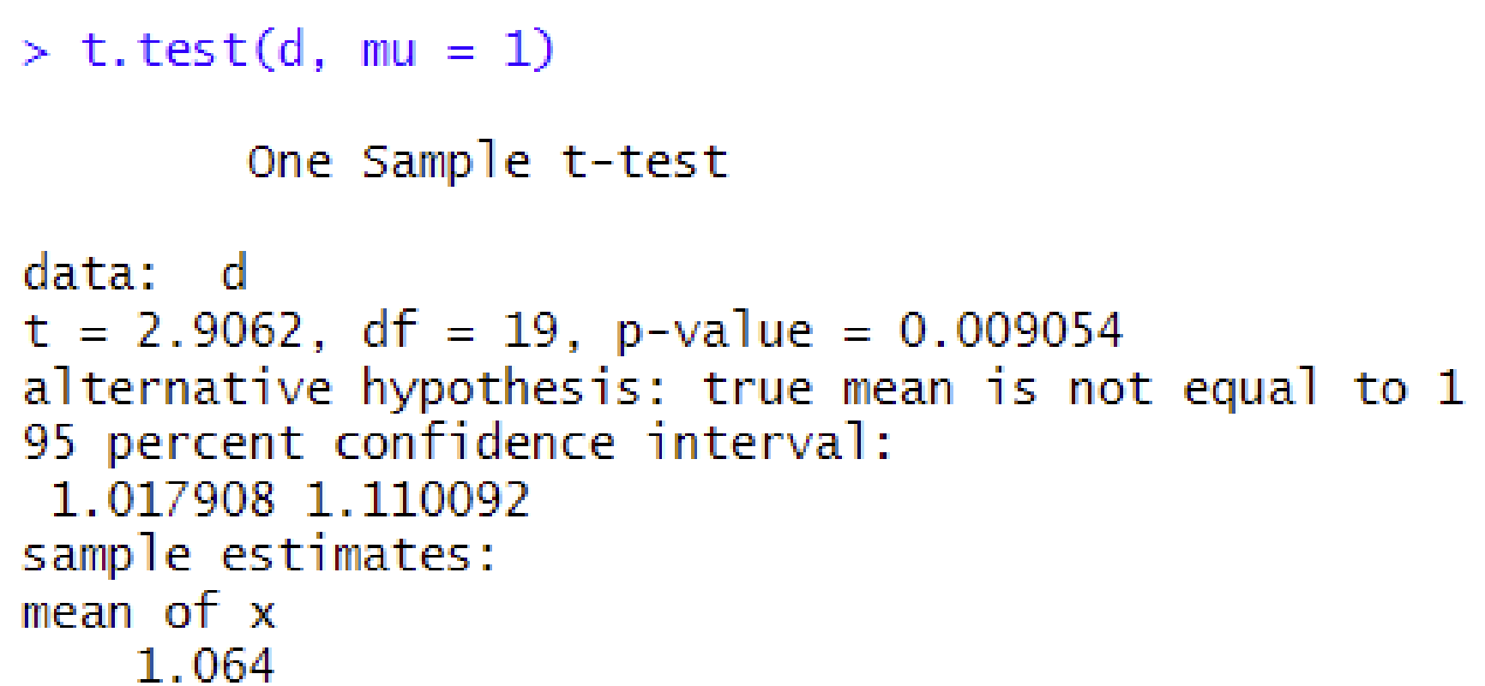

**Testing Correlation of two cols in R:**

-use: cor.test(x=d$vmax, y=d$vo2max)

-outputs p value and CI for the true Pearson correlation (of the two r.v., from which we sampled)

Example output:

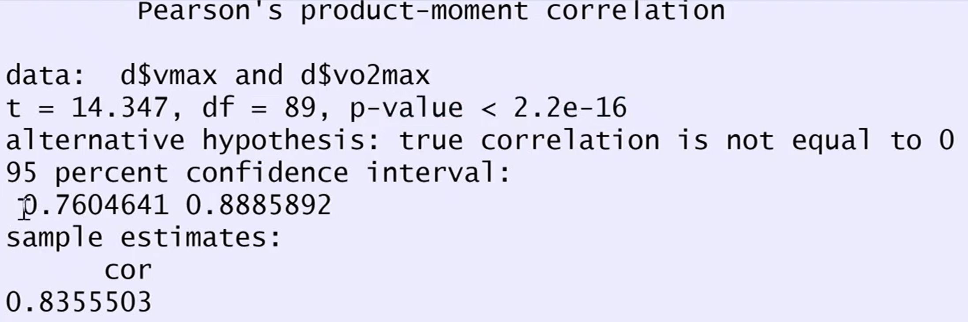

**Testing Variance of two samples in R:**

var.test(est1, est2) (output similar to above)

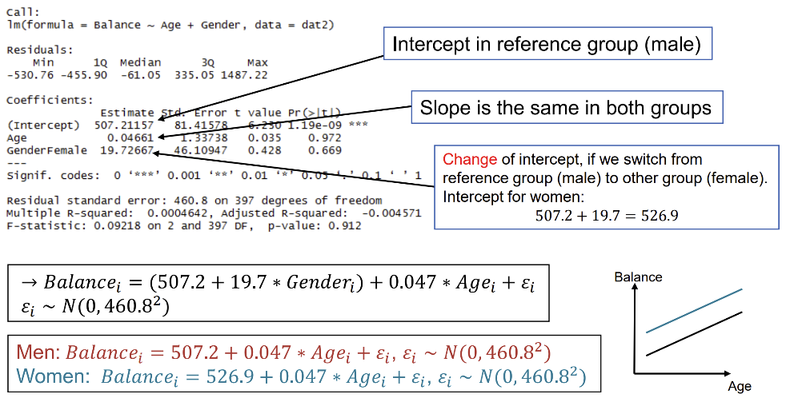

**Linear Regression in R:**

-**simple** linear regression of col y against col x from df:

fm <- lm(y ~ x, data = df)

-**multiple** linear regression:

fm <- lm(y ~ col1 + col2 + col3, data=df)

summary(fm)

Example summary output:

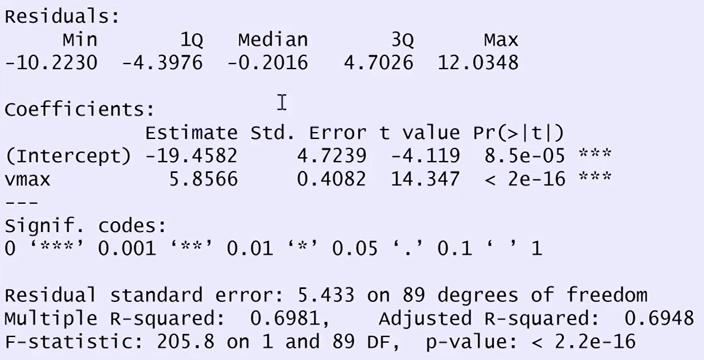

-**coefficients**: estimated param. vals and their resp. std and p-values (for estimating the true param values)

-**slope interpretation**: y-value changes by “vmax” for every 1-value-increase in the explanatory variable x

- predicted coefficients of lin.model: coefficients(fm)

Example coefficients output: y ~ intercept + vmax * x

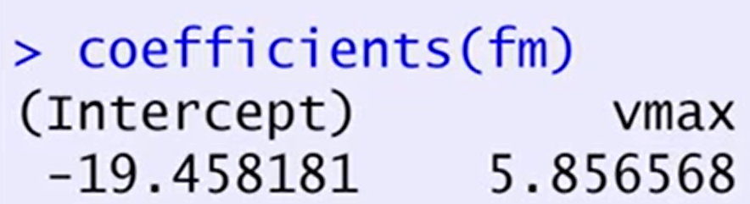

-**predict** on new data:

newdf <- data.frame(ProteinG = 10, KohlenhG = 5, FettG = 7)

predict(fm, newdata = newdf)

- predict value of derivative: add attribute deriv = 1

- **also output CI**: predict.lm(fm, newdata = newdf, interval = "confidence", level=0.99)

- also output **prediction interval**: predict.lm(fm, newdata = newdf, interval = "prediction", level=0.99)

-**Covariance matrix** of $\hat{β}$  of our model: vcov(fm)

**Multiple Linear Regression (MLR):**

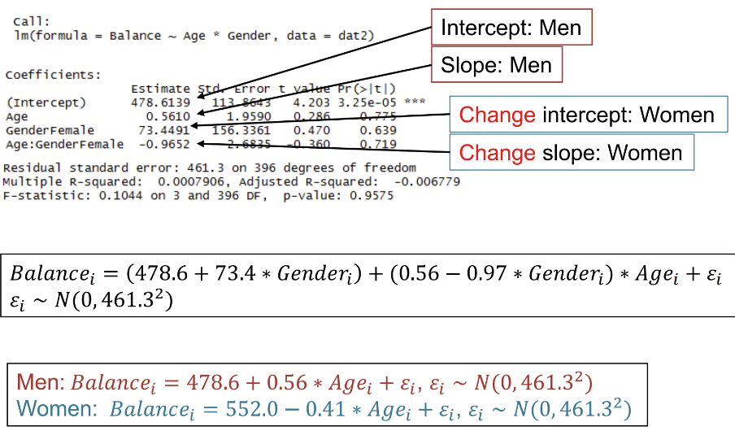-**residuals** of observations $Y_{i}$: residuals_y <- residuals(lm(y ~ col1 + col1, data=df))

**Reference Levels and Interactions in R:**

-**factor variables** (discretely valued: “**levels**”): intrinsic ordering of levels inR .Show reference level: levels(df$col)

- **change reference level**: relevel(df$col, ref=”fem”)

-R encodes reference levels using “dummy variables”:

Ex.:

- fit same slope to all param, but different intercepts

- corresponds to intercept of reference level

-**manually factorize** a (discretely valued) col in a dataframe (necessary for linear regression):

df$col <- factor(x=df$col, levels = c("Male", "Female")) ## first level is ref.level

-**factorize while reading** file:

df <- read.csv(file = "data.csv", row.names = 1, header = TRUE, stringsAsFactors = TRUE)

**Example** output:(linear regression with factor variable gender)

**[*output maybe not so important*]**

- note: the slope (of age) stays the same over all levels.

-**interaction:** if the slope wrt. another param. also changes between levels (/groups). We then say these explanatory variables have interaction.

-only use interaction if really necessary (!)

-**Illustration of interaction** between age and gender:

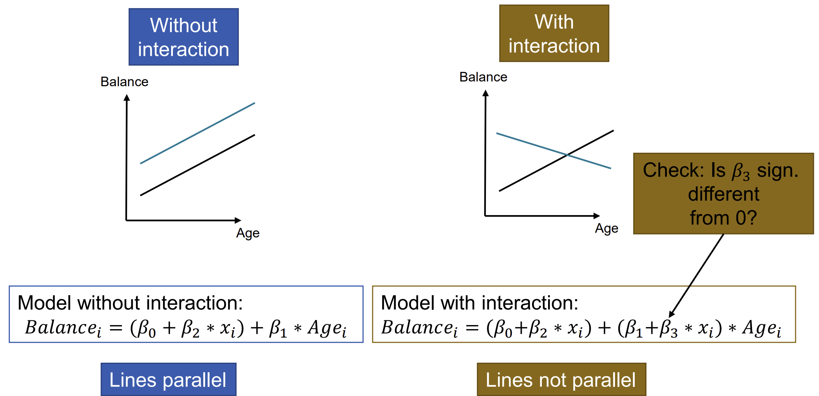 -note: **intercepts will not stay the same across both models!**

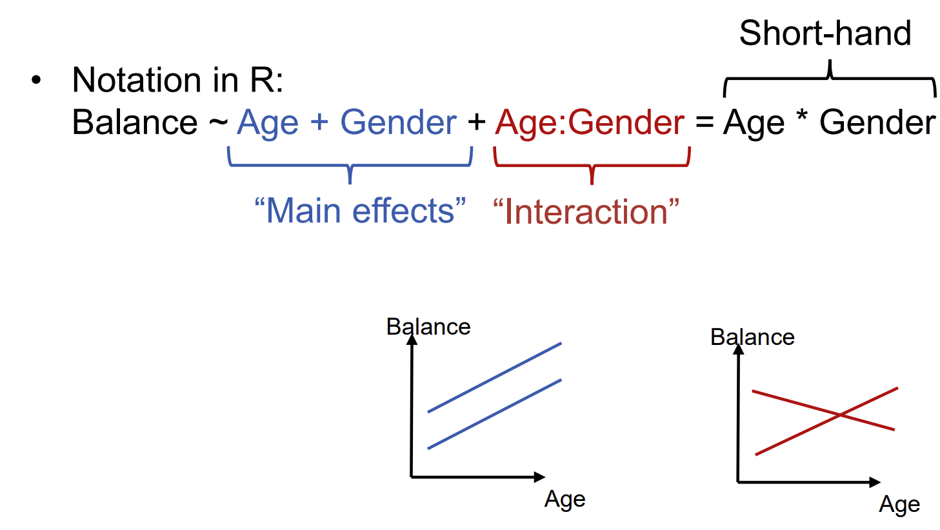

**Example** output of interactions:

**Understanding the linear model output in R:**

-**confidence interval** (CI) of fitted parameters:

confint(fm, level=0.99)

- fitted parameters are t-distributed (degree of freedom n-p); using this information we can construct the CI.

**Example output: linear model**

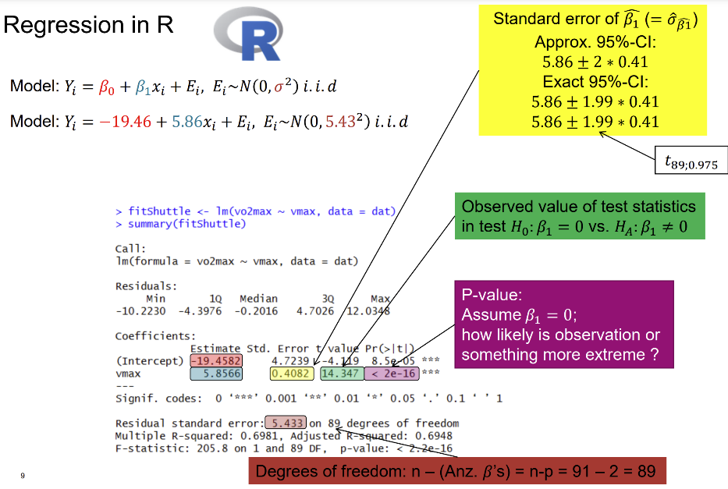 🡪 **std.error**: standard deviation of estimated parameter

🡪 **t-value**: observed value of statistic for test .

🡪 **residual standard error**: error estimate of noise std

🡪**F-statistic**: statistic value of test $H_{0}:$ all param. are 0.

-high test statistic value / low p-value indicates high overall significance of the model

-**Variance inflation factor**:

- score for each variable: **high values** indicate that the variable is **highly correlated** with other parameters

- is found through regression of $i$-th var. against others

- VIF is factor in variance term of ${\hat{β}}_{i}$

$→$**high dependency reduces accuracy**

-**sign of collinearity**: overall high p-values, but low F-Test values!

-In **R** we have: vif(fm)

-**Rule of thumb**: $VIF$ < 4: ok; 4 < $VIF$ < 10: borderline; $VIF$ > 10: problematic => "first aid": remove variable

**Contrasts in R:**

-problem: compute CI of contrasts, e.g. have interaction but want to **find CI of a parameter given a non-reference level**

-find CI **manually**: get CI of parameter given a non-reference level (with corresponding contrast):

contrast <- rbind("param_level_slope" = c(0,0,1,1))

glhtfmI <- glht(fm, linfct = contrast)

summary(glhtfmI)

confint(glhtfmI) ## watch out for multiple testing correction, if more hypotheses are included

-**find CI by** **refitting** (faster): change the reference level to the level of interest, then re-run the fitting (might be faster)

**Partial F-testing in R:**

-first fit full linear model, and then fit partial linear model. Compare models using anova():

fm <- lm(y ~ x1 + x2 + x3 + x4 + x5, data=df)

fm2 <- lm(y ~ x1 + x2, data=df)

anova(fm, fm2)

**Residual Analysis plots in R:**

-diagnostic plots like **tukey-anscombe and QQ-plot**:

plot(fm, which = 1:3)

-many outliers indicate bad model e.g. should add a variable

**Model Selection in R:**

-**exhaustive search** (nvmax: max number of considered variables): model1 <- regsubsets(y ~ ., data = dTrain, method = "exhaustive",nvmax = 10)

-**forward search**: model2 <- regsubsets(y ~ ., data = dTrain, method = "forward")

-**backward search**: model3 <- regsubsets(y ~ ., data = dTrain, method = "backward")

-**search methods output**: rows which for each number of variables shows us the optimal combination of variables.

-**compare $C_{p}$ values** **of all tested models**:

ncoef<-which.min(model1_summary$cp)

coef(m1, ncoef)

- **alternatively**: model1_summary<- summary(model1) model1_summary$cp

🡪**output**: column of $C_{p}$ values (choose model with lowest val)

-**graphical view**: plot(model1, scale = "Cp")

-compute **MSE of predictions** (manually):

fmFull <- lm(y ~ ., data = dTrain)

yHat <- predict(fmFull, newdata = dTest)

mseFull <- mean( (yHat - dTest$y)^2)

**Non-iid errors in R:**

-**WLS (weighted least squares):** Given an observation is the average of n single observations, we scale the new variance to be $\frac{σ^{2}}{n}$: fm <- lm(y ~ x, data = df, weights = nreps)

-nreps= #observations which make up a value (average)

-**heteroscedasticity**: **variances in normal summary are wrong!**

🡪sandwich estimator to adapt error variances

-use the **sandwich estimator** to do linear regression with data that exhibits heteroscedasticity. This adapts the wrong variances for the confidence intervals of a fitted linear model

-**new** **coefficient output** with adapted std:

coeftest(fm, vcov = vcovHC(fm, type = "HC0"))

-**new** **confidence interval**:

coefci(fm, vcov = vcovHC(fm, type = "HC0"))

**Linear Mixed Models:**

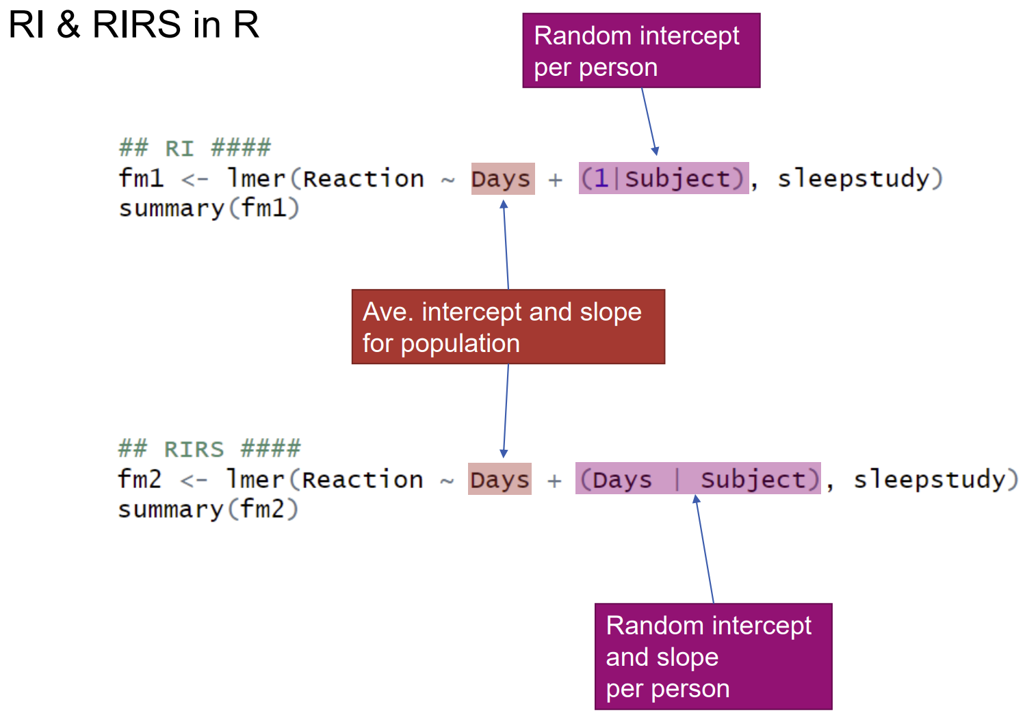

**Example Output: RI & RIRS**

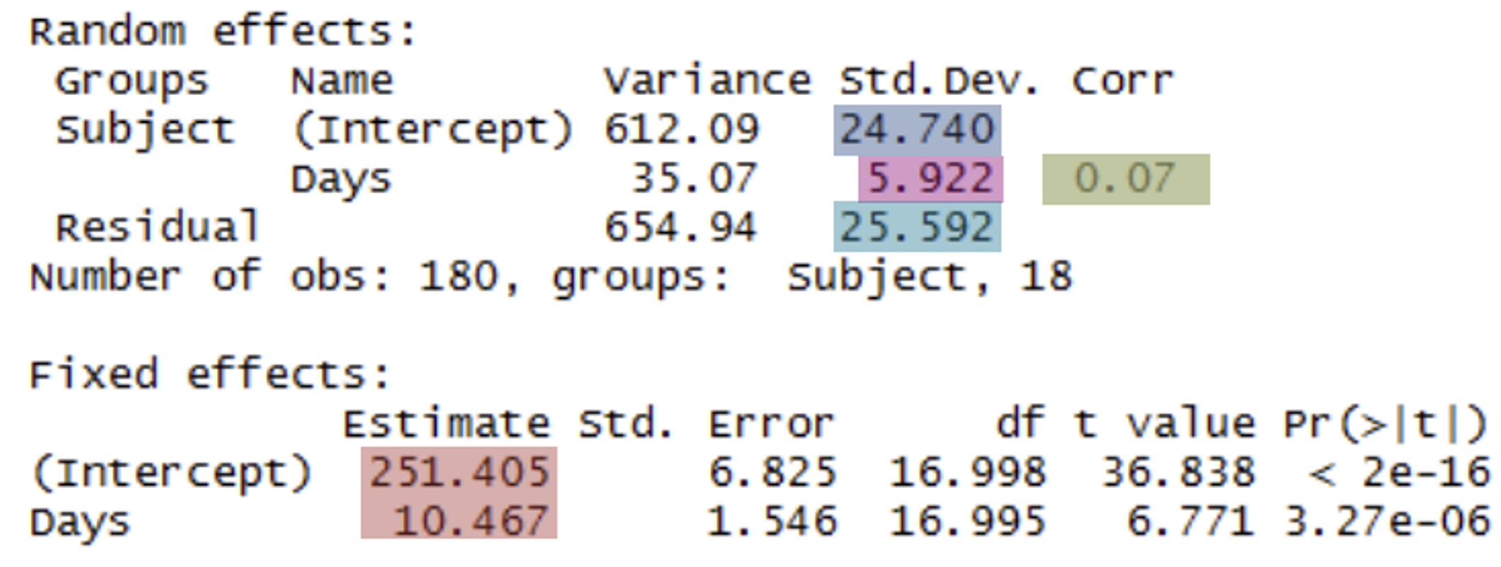

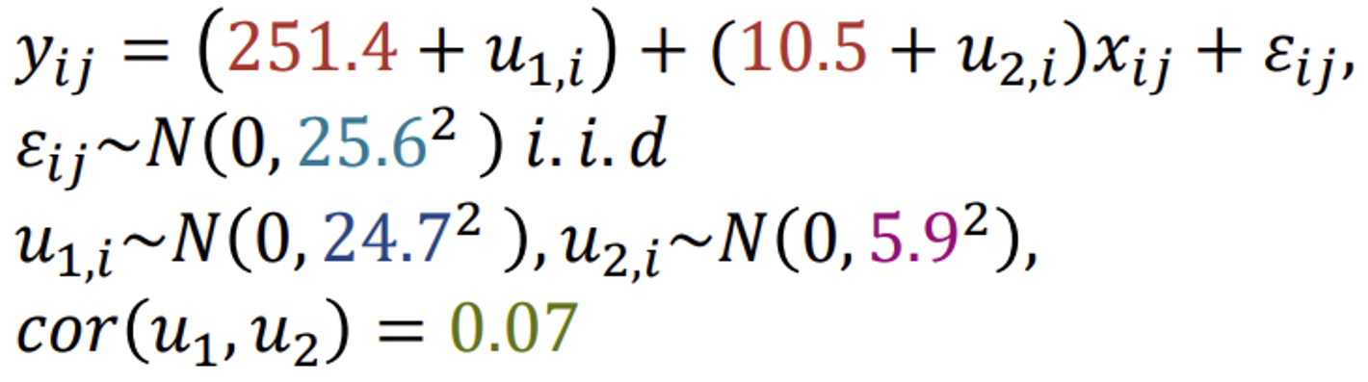

-**output random effects**: describes the estimated standard deviations of each random effect r.v. $u_{i}$

-get **confidence intervals of parameters**:

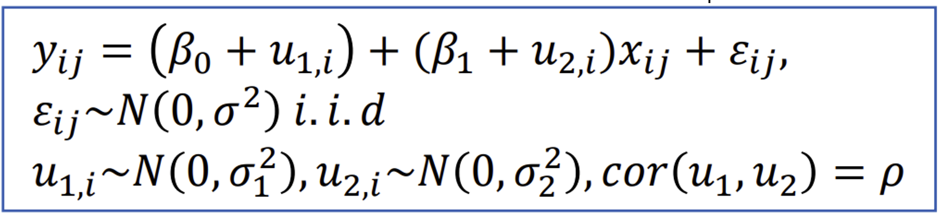

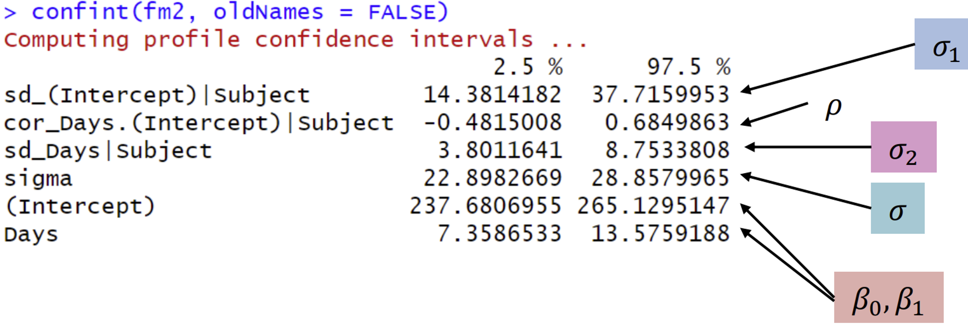

**Example output association**: of CI with summary

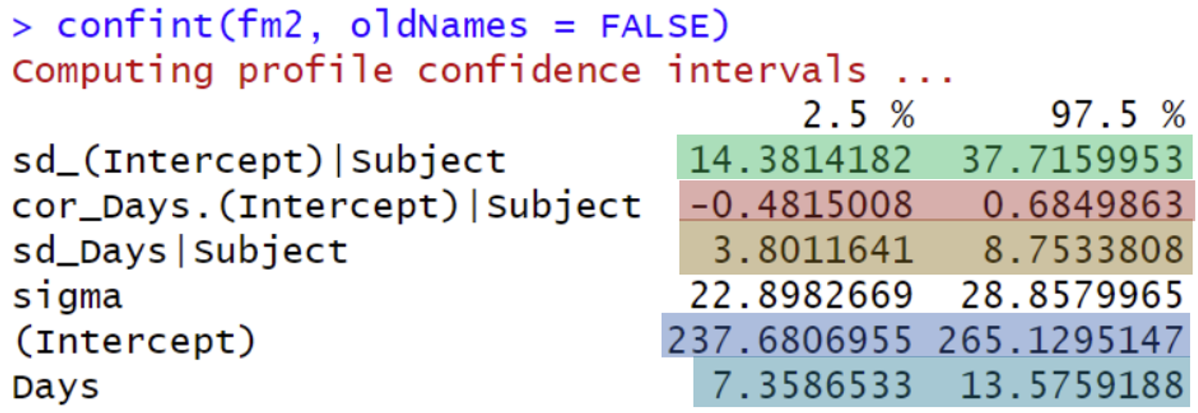

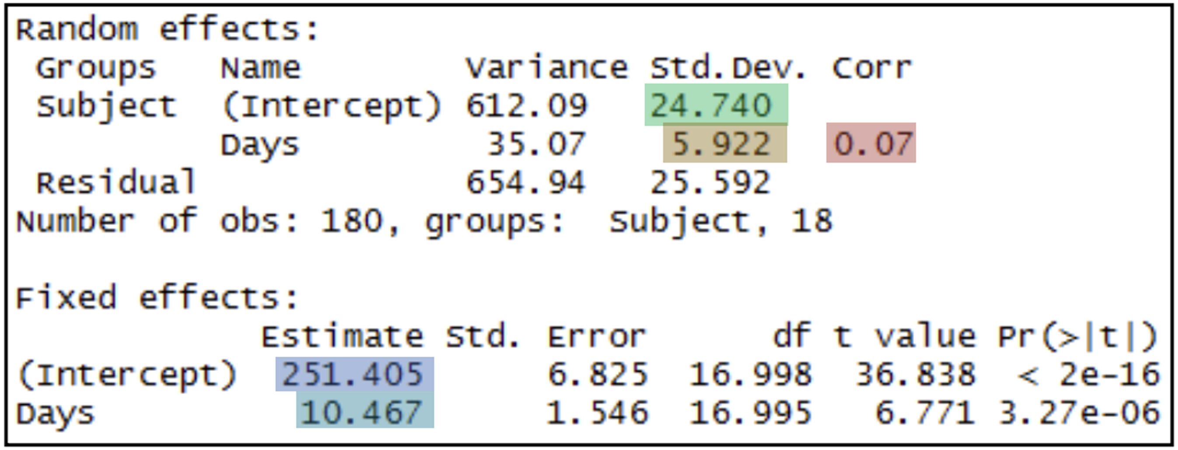

-estimates of the **random effects of each individual**:

ranef(fm)

**GLM (general linear model) Logistic Regression in R:**

-GLM logistic regression: model the probability of a binary random variable

**-**glm() **models probability for the non-reference level!!**

-note: a change of 1 unit in any variable has **multiplicative or additive change w.r.t. the scale**

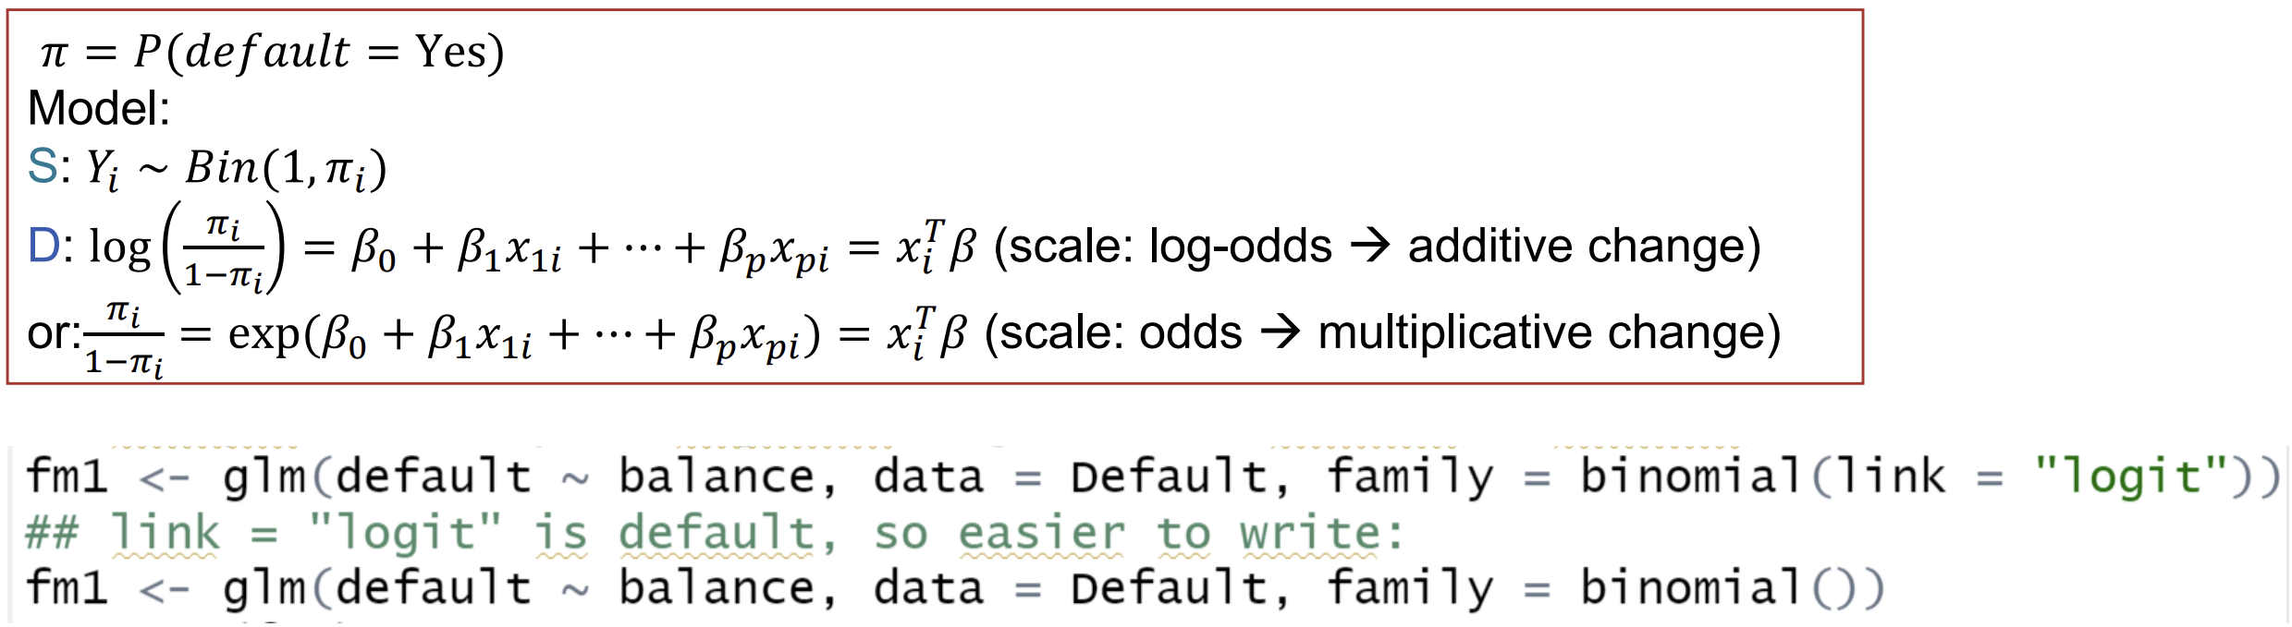

-Note: $β$ **param. are modeled w.r.t. log-odds scale here!!**

- thus std, and corresponding CI are on log-odds scale

- apply exp() to **extract odds-ratio and CI of odds-ratio**!

🡪 exp(coef(fm)) **OR** exp(confint_fm)

-compute **(log-)odds** and **probabilities** from the **GLM model**:

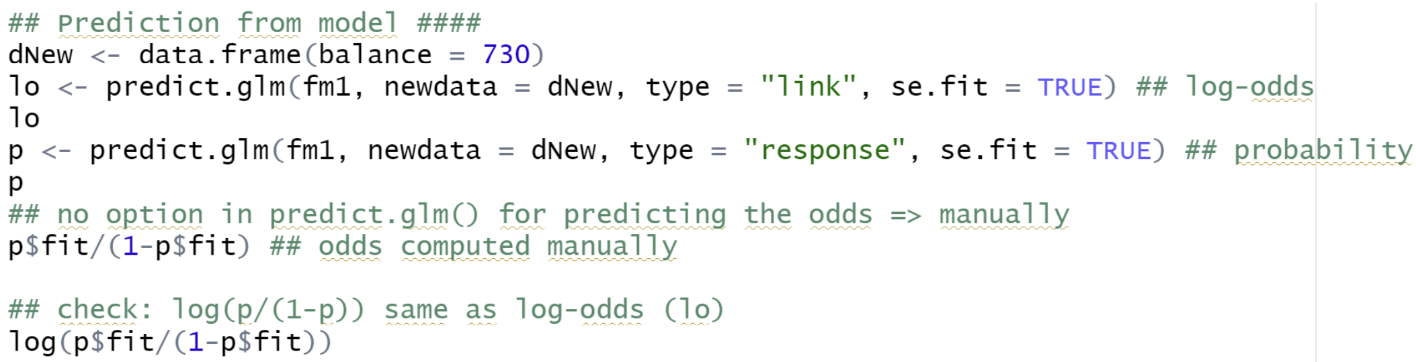

**GLM examples**:

-**Poisson regression** (e.g. for counting incidents): Assume $Y_{i}\sim Pois\left(λ_{i}\right)→ μ_{i}=E\left(Y_{i}\right)=Var\left(Y_{i}\right)=λ_{i}$. **Problem**: if we **expect larger values**, their **variance** will **grow** aswell! $D:\log\left(μ_{i}\right)=\log{{(λ}_{i})}= x_{i}^{T}β ; S: Y_{i} ∼ Pois\left(λ_{i}\right)$

-in **R**: we use glm with: family=poisson() or family=quasipoisson()

-Gamma Regression:

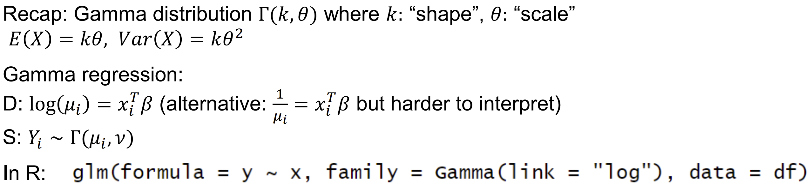

**Comparing Models:**

-**Residual Deviance**: receive a squared deviance residual $d_{i}$ for every parameter; compute **squared sum deviance**:

sum(residuals(fm, type = "deviance")^2)

**Nonlinear regression in R:**

-run nonlinear regression with **manually chosen starting values**:

fm <- nls(yObs ~ t1*exp(-t2*t3^x), data = df,

start = c(t1= 12, t2= 5, t3= 0.5))

-for some nonlinear functions there are **optimized self-starting functions** like SSgompertz:

fm <- nls(yObs ~ SSgompertz(x, Asym, b2, b3), data = df)

-summary output of nls() std values can be used to construct **Wald-Type CI**

- But: **assumes symmetry** in distr. around estimate (MLE)

- **instead**: compute **CI based on profile likelihood** (i.e. likelihood drop). This is automatically done by: confint(fm)

**Nonparametric Regression in R:**

-estimate function with **no knowledge about functional form**

-estimate using **polynomial**:

fm_p10 <- lm(y ~ poly(x, degree = 10))

-**kernel regression:** use a weighted window for a moving “average”. The weights are given by the kernel function:

y_ks <- ksmooth(x,y,kernel = "normal", bandwidth = 0.01, x.points = x)$y

- with x.points we request predictions on other points

-**local polynomial regression**. Fit a polynomial inside the window, but only keep the intercept:

fm_lp <- locpoly(x,y,drv = 0, degree = 1, kernel = "normal",

bandwidth = 0.005)

-drv=0: set derivative to 0; degree=1: degree of polynomials (usually not higher than 2)

-**smoothing spline** (works best, and fast):

fm_ss <- smooth.spline(x,y, cv = TRUE)